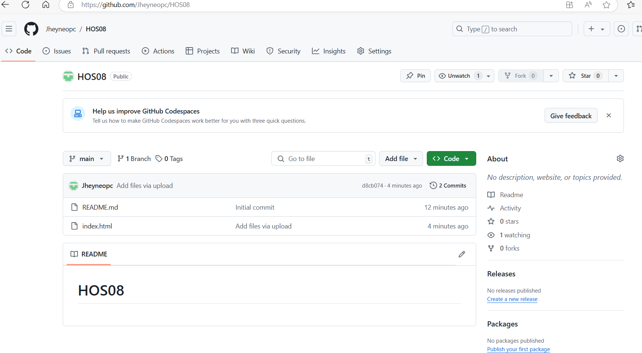

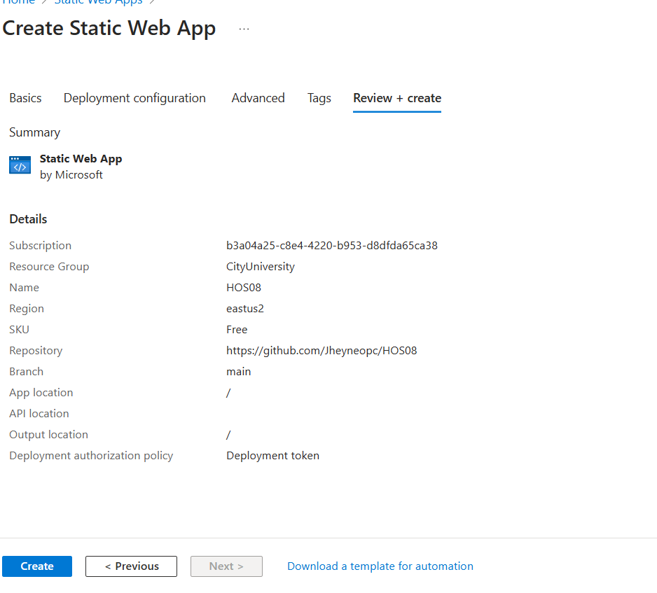

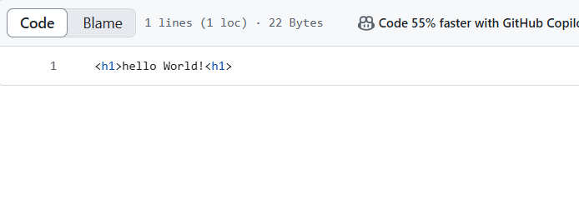

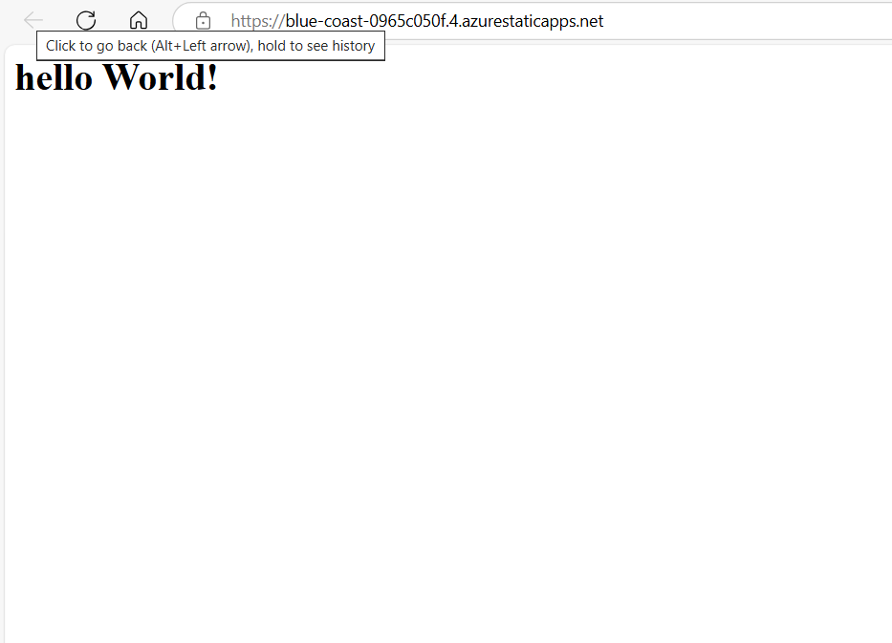

Process was deleted

